Autumn 1 | Autumn 2 | Spring 1 | Spring 2 | Summer 1 | Summer 2
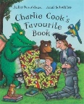 | 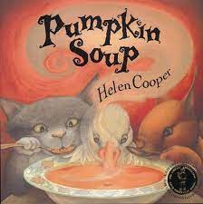 |  | 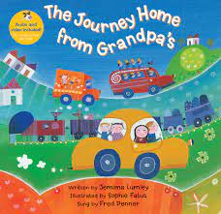 | 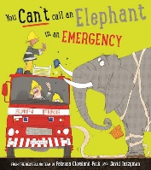 | 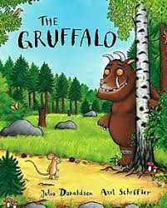
Purpose: N/A  Outcome: Initial sound  Themes: Love of reading | Purpose: N/A  Outcome: CVC word  Themes: Friendship and Teamwork | Purpose: N/A  Outcome: Simple phrase  Themes: Understanding the environment | Purpose: N/A  Outcome: Simple phrase  Themes: Journeys | Purpose: N/A  Outcome: Sentence  Theme: People and Communities | Purpose: Entertain  Outcome: Sentence  Themes: Acceptance and Bravery
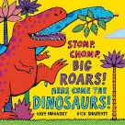 | 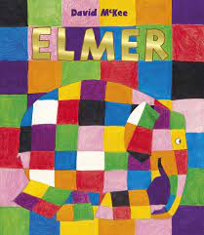 | 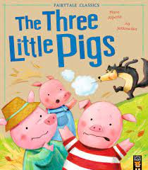 | 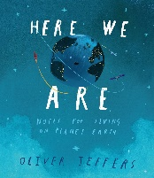 | 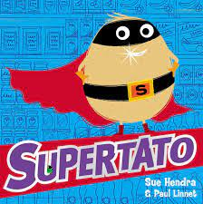 | 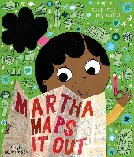
Purpose: N/A  Outcome: Initial sound  Themes: Rhyming | Purpose: N/A  Outcome: CVC word  Themes: Celebrating Differences | Purpose: N/A  Outcome: Simple phrase  Themes: Traditional Tale | Purpose: N/A  Outcome: Simple phrase  Themes: Sustainability and Diversity | Purpose: N/A  Outcome: Sentence  Themes: Resilience and Caring | Purpose: Entertain  Outcome: Sentence  Themes: Diversity
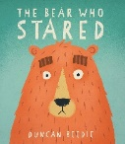 | 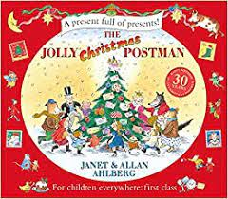 | 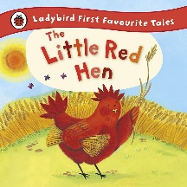  Purpose: N/A  Outcome: Simple phrase  Themes: Traditional Tale | 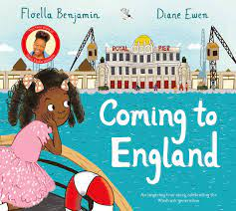 | 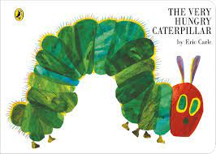  Purpose: N/A  Outcome: Sentence  Themes: Changes | 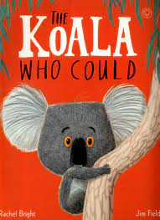
Purpose: N/A  Outcome: Initial sound  Themes: Social Skills | Purpose: N/A  Outcome: CVC word  Themes: Links to Traditional Tales / kindness |  | Purpose: N/A  Outcome: Simple phrase  Themes: Diversity |  | Purpose: Entertain  Outcome: Sentence  Themes: Change and Resilience


Piper – Pixar short clip
Purpose: N/A
Outcome: Oracy
Theme: Resilience
Purpose: N/A
Outcome: Initial sound
Our key threads are: equality, the environment and sustainability including outdoor learning and mental and emotional wellbeing.
Early Learning Goals:
Fine motor skills:
Children at the expected level of development will:
- Hold a pencil effectively in preparation for fluent writing – using the tripod grip in almost all cases.

Writing:
Children at the expected level of development will:
- Write recognisable letters, most of which are correctly formed;
- Spell words by identifying sounds in them and representing the sounds with a letter or letters;
- Write simple phrases and sentences that can be read by others.

