Autumn 1 | Autumn 2 | Spring 1 | Spring 2 | Summer 1 | Summer 2
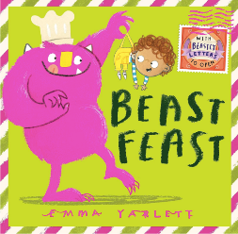 | 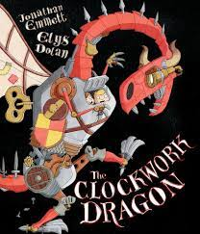 | 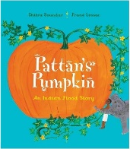 | 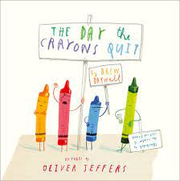 | 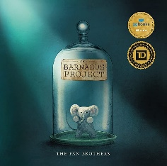 | 
Purpose: Entertain  Outcome: Description  Theme: Diversity | Purpose: Inform  Outcome: Letter  Theme: ingenuity, bravery and overcoming adversity | Purpose: Entertain  Outcome: Narrative  Theme: Diversity, resourcefulness, community and the power of nature | Purpose: Persuade  Outcome: Letter  Theme: empathy, communication and creativity | Purpose: Inform  Outcome: Fact-file  Theme: Diversity- acceptance and belonging | Purpose: Persuade  Outcome: Letter  Theme: Film Migrant refugee diversity climate change
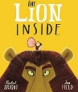 | 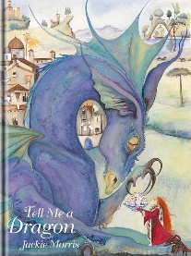 | 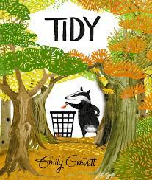 | 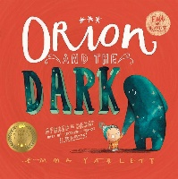 |  | 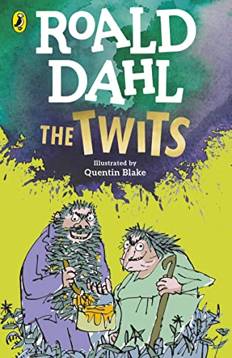
Purpose: Entertain  Outcome: Narrative  Theme: courage, self-confidence and friendship | Purpose: Entertain  Outcome: Char Desc  Theme: Diversity | Purpose: Persuade  Outcome: Letter  Theme: Sustainability and caring for the environment | Purpose: Entertain  Outcome: Description  Theme: overcoming fears HIAS | Purpose: Entertain  Outcome: Poster  Theme: Diversity- acceptance and belonging | Purpose: Inform  Outcome: Poster  Theme: Heritage (req)  morality and importance of kindness and empathy
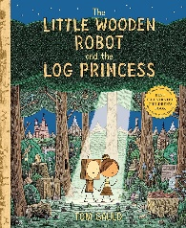 | 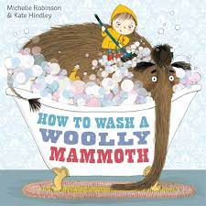 |  |  | 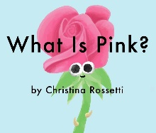 | 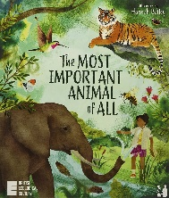
Purpose: Entertain  Outcome: Narrative  Theme: sibling love, bravery, adventure and overcoming fears. | Purpose: Inform  Outcome: Instructions  Theme: Resilience HIAS |  |  | Purpose: Entertain  Outcome: Poem  Theme: Poetry (req) | Purpose: Persuade  Outcome: Fact-file
Our key threads are: equality, the environment and sustainability including outdoor learning and mental and emotional wellbeing.

National Curriculum objectives:
Handwriting:
Pupils should be taught to:
- form lower-case letters of the correct size relative to one another
- start using some of the diagonal and horizontal strokes needed to join letters and understand which letters, when adjacent to one another, are best left unjoined
- write capital letters and digits of the correct size, orientation and relationship to one another and to lower case letters
- Use spacing between words that reflects the size of the letters.
Composition:
Pupils should be taught to:
- develop positive attitudes towards and stamina for writing by:
  - writing narratives about personal experiences and those of others (real and fictional)
  - writing about real events
  - writing poetry
  - writing for different purposes
- consider what they are going to write before beginning by:
  - planning or saying out loud what they are going to write about
  - writing down ideas and/or key words, including new vocabulary
  - encapsulating what they want to say, sentence by sentence
- make simple additions, revisions and corrections to their own writing by:
  - evaluating their writing with the teacher and other pupils
  - re-reading to check that their writing makes sense and that verbs to indicate time are used correctly and consistently, including verbs in the continuous form
  - proof-reading to check for errors in spelling, grammar and punctuation [for example, ends of sentences punctuated correctly]
- Read aloud what they have written with appropriate intonation to make the meaning clear.
Spelling:
Pupils should be taught to:
- spell by:
  - segmenting spoken words into phonemes and representing these by graphemes, spelling many correctly
  - learning new ways of spelling phonemes for which one or more spellings are already known, and learn some words with each spelling, including a few common homophones
  - learning to spell common exception words
  - learning to spell more words with contracted forms
  - learning the possessive apostrophe (singular) [for example, the girl’s book]
  - distinguishing between homophones and near-homophones
- add suffixes to spell longer words, including –ment, –ness, –ful, –less, –ly
- apply spelling rules and guidance, as listed in English Appendix 1
- Write from memory simple sentences dictated by the teacher that include words using the GPCs, common exception words and punctuation taught so far.
Vocabulary, grammar and punctuation:
Pupils should be taught to:
- develop their understanding of the concepts set out in English Appendix 2 by:
  - learning how to use both familiar and new punctuation correctly (see English Appendix 2), including full stops, capital letters, exclamation marks, question marks, commas for lists and apostrophes for contracted forms and the possessive (singular)
- learn how to use:
  - sentences with different forms: statement, question, exclamation, command
  - expanded noun phrases to describe and specify [for example, the blue butterfly]
  - the present and past tenses correctly and consistently including the progressive form
  - subordination (using when, if, that, or because) and co-ordination (using or, and, or but)
  - the grammar for year 2 in English Appendix 2
  - some features of written Standard English
- Use and understand the grammatical terminology in English Appendix 2 in discussing their writing.

