Autumn 1 | Autumn 2 | Spring 1 | Spring 2 | Summer 1 | Summer 2
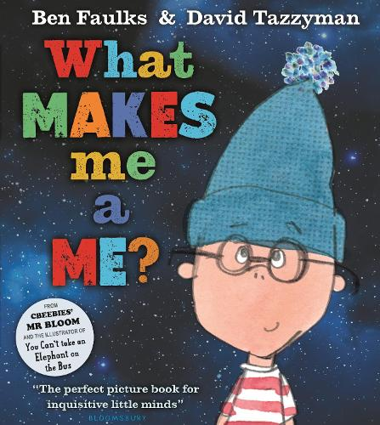 | 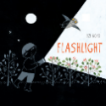 | 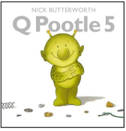 | 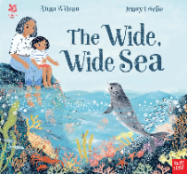 |  | 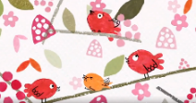
Purpose: Entertain  Outcome: Sentences  Themes: individual identity, self-awareness, and uniqueness | Purpose: Entertain  Outcome: Narrative  Themes: Exploration, curiosity and the natural world | Purpose: Inform  Outcome: A list  (HIAS)  Themes: space adventure, friendship and problem solving | Purpose: Persuade  Outcome: Article  Theme: nature, environmentalism and sustainability | Purpose: Inform  Outcome: Letter  Theme: Regulation of emotions- imagination, anger, love and importance of home | Purpose: Inform  Outcome: Recount  Themes: Resilience and problem solving
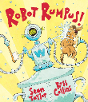 | 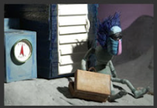 | 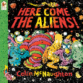 |  | 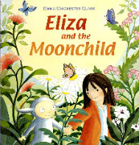 | 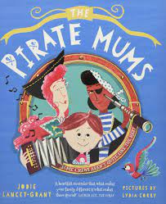
Purpose: Entertain  Outcome: Sentences  Themes: Responsibility, consequences and family | Purpose: Inform  Outcome: Report  Themes: imagination, isolation and loneliness | Purpose: Entertain  Outcome: Narrative  Themes: Diversity | Purpose: Entertain  Outcome: Postcard  Theme: survival, self-discovery, friendship and nature | Purpose: Entertain  Outcome: Poem  Themes: friendship and discovery | Purpose: Persuade  Outcome:  Theme: family diversity and acceptance
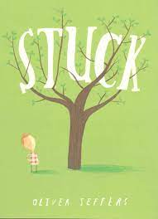 | 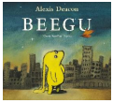 | 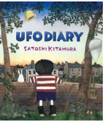 | 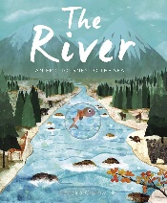 |  | 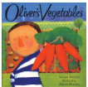
Purpose: Entertain  Outcome: Sentences  Theme: Outdoor learning, resilience and problem solving | Purpose: Inform  Outcome: Letter  (HIAS)  Themes: hope, friendship and inclusion | Purpose: Entertain  Outcome: Narrative  (HIAS)  Themes: Friendship, empathy and overcoming language barriers through non-verbal communication | Purpose: Entertain  Outcome: Descriptive  Theme: Sustainability |  | Purpose: Inform  Outcome: Letter  (HIAS DT link)  Themes: Healthy eating and the connection between food and nature
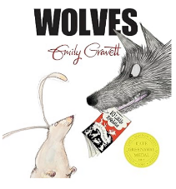
Purpose: Inform
Outcome: Sentences
Themes: Diversity (everyone is different)
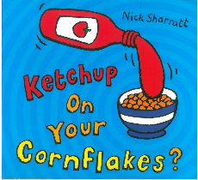
Purpose: Entertain
Outcome: Sentences
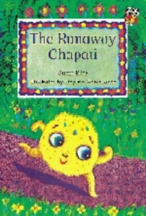
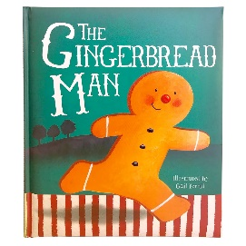
Purpose: Entertain
Outcome: Sentences
Themes: Diversity and similarities between cultures
Our key threads are: equality, the environment and sustainability including outdoor learning and mental and emotional wellbeing.
National Curriculum objectives:
Spelling:
Pupils should be taught to:
- spell:
  - words containing each of the 40+ phonemes already taught
  - common exception words
  - the days of the week
- name the letters of the alphabet:
  - naming the letters of the alphabet in order
  - using letter names to distinguish between alternative spellings of the same sound
- add prefixes and suffixes:
  - using the spelling rule for adding –s or –es as the plural marker for nouns and the third person singular marker for verbs
  - using the prefix un–
  - using –ing, –ed, –er and –est where no change is needed in the spelling of root words [for example, helping, helped, helper, eating, quicker, quickest]
- apply simple spelling rules and guidance, as listed in English Appendix 1
- Write from memory simple sentences dictated by the teacher that include words using the GPCs and common exception words taught so far.

Handwriting:
Pupils should be taught to:
- sit correctly at a table, holding a pencil comfortably and correctly
- begin to form lower-case letters in the correct direction, starting and finishing in the right place
- form capital letters
- form digits 0-9
- Understand which letters belong to which handwriting ‘families’ (i.e. letters that are formed in similar ways) and to practise these.

Composition:
Pupils should be taught to:
- write sentences by:
  - saying out loud what they are going to write about
  - composing a sentence orally before writing it
  - sequencing sentences to form short narratives
  - re-reading what they have written to check that it makes sense
- discuss what they have written with the teacher or other pupils
- Read aloud their writing clearly enough to be heard by their peers and the teacher.

Vocabulary, punctuation and grammar:
Pupils should be taught to:
- develop their understanding of the concepts set out in English Appendix 2 by:
  - leaving spaces between words
  - joining words and joining clauses using and
  - beginning to punctuate sentences using a capital letter and a full stop, question mark or exclamation mark
  - using a capital letter for names of people, places, the days of the week, and the personal pronoun ‘I’
  - learning the grammar for year 1 in English Appendix 2
- Use the grammatical terminology in English Appendix 2 in discussing their writing.

